TABLE S:
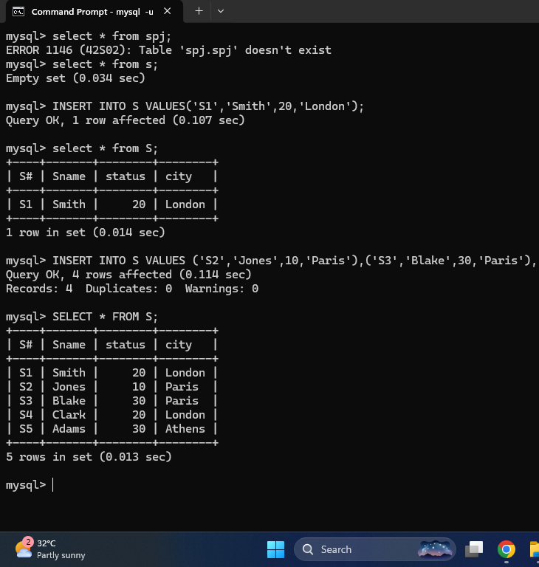

TABLE P:
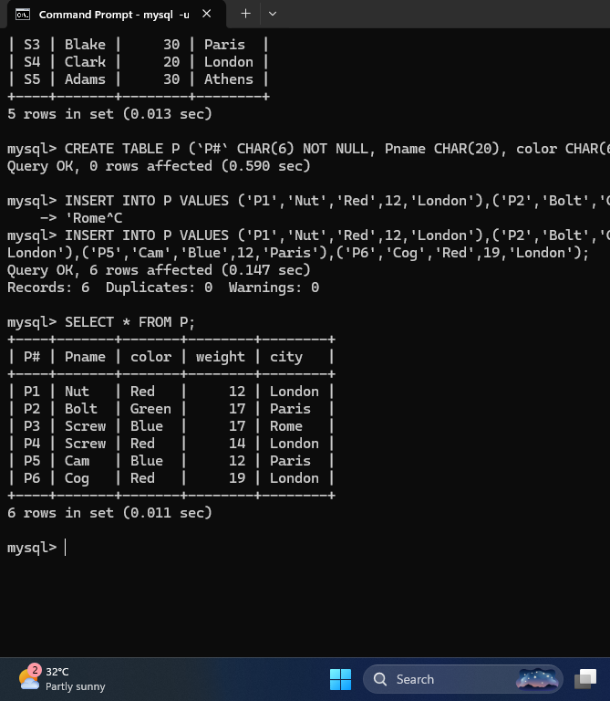

TABLE J:
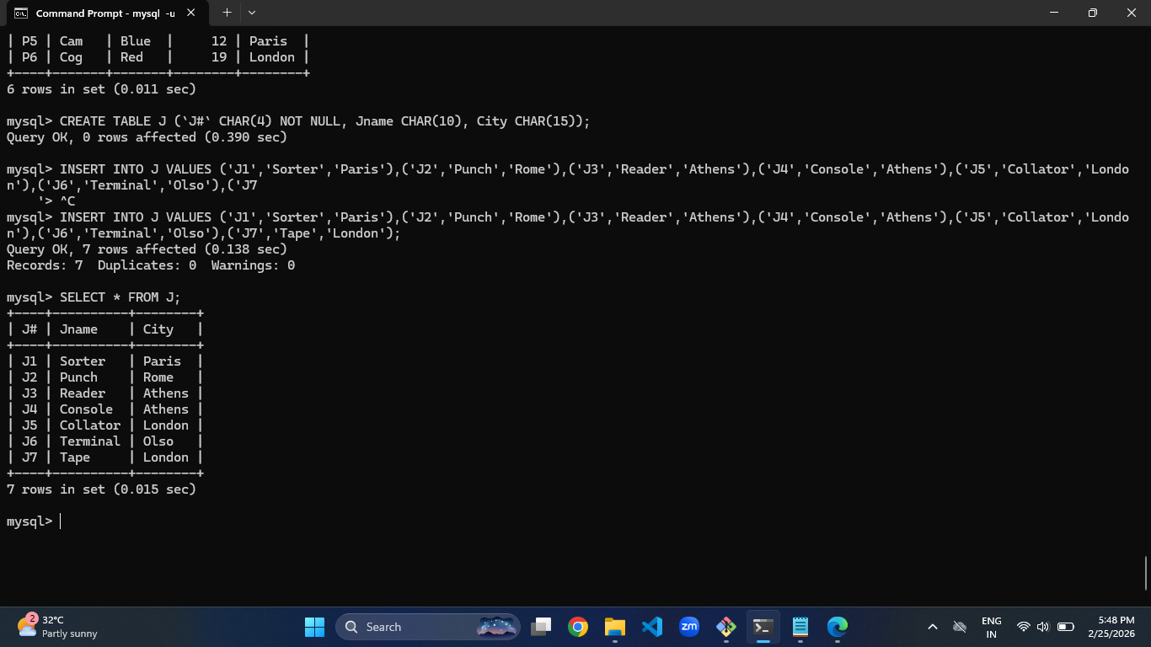

TABLE SP:
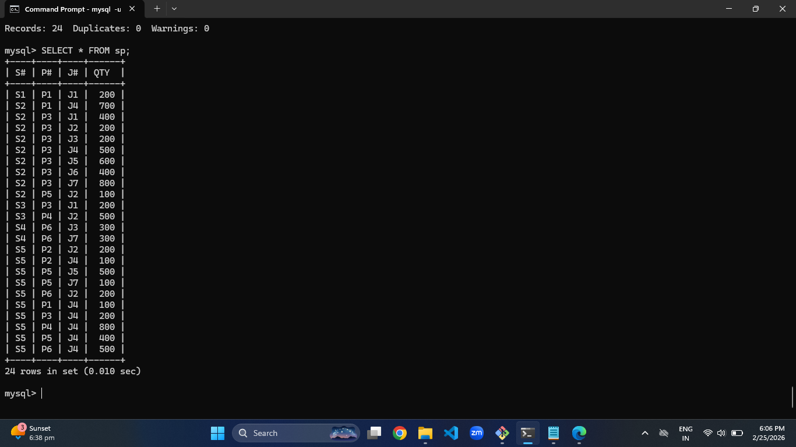

ASSIGNMENT 1 QUESTIONS AND ANSWERS:

1. How many orders data is present in the database? =10
2. How many customers are present in the database? =7
3. How many salespeople are present in the database? =5
4. On which date order with highest amount is placed? = 1990-10-04
5. For which order salesman got maximum commission? = 3006
Hint: you need to refer data of two tables.
6. Which salesmen are handling more than two customers? Hint: you need to refer data of two tables. = None
7. Which city have single customer? =Berlin
8. Which city has multiple salespeople? = London
9. What is name of customer and salesman of the maximum amount order? = Clemens & Peel
10. Study relationship between the tables in sales database.

